Using ESF – 8 Portal
- A link to the ESF-8 Portal log on page can be found on the Dept. Health and Hospital web page http://www.dhh.louisiana.gov/ look in the RIGHT margin for the ESF-8 Portal link.
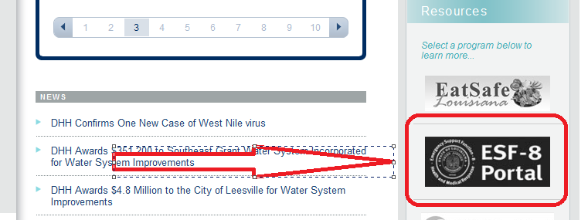

- If you need additional guidance, access multiple documents regarding how to and new user training information click the “Public Documents” link found on the Log on Page for the ESF-8 Portal. (these documents are accessible without a user name or password)
Note: Once you open “Public Documents” look on left under “ESF8 Documents” for New User Training Material
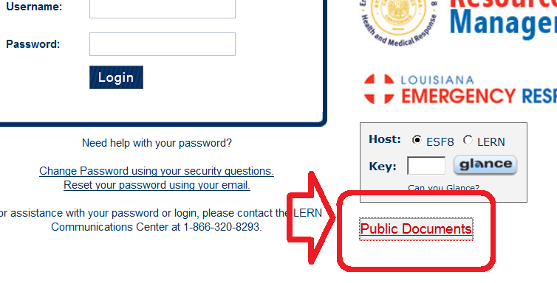
- Log In: Use the Username & Password you used to log into EMSTAT;
- If you have trouble logging:
- If you did not have an EMSTAT User Name and Password OR If your User Name and Password do not work OR If you do not know or do not have User Name and Password you will need to contact LERN Communications Center at 1-866-320-8293 to get password or to reset password. You can also contact Malcolm Tietje at malcolm.tietje@la.gov (225 )342-2390; OR Ms. Mary Sept, Mary.Sept@la.gov (225) 342-3240.
- If you have logged in before and have current information in ESF-8 then you can use the option of:
- Change Password using your security questions. This will only work if you have picked your security questions and entered your answers.
- NOT YET FUNCTIONAL – do not use- Reset your password using your email. This will only work if your current email information is correct. NOT YET FUNCTIONAL
- If i. or ii. Do not work see 4.a. (Call or Email assistance)
- Once you have logged into the portal you should see “Welcome Your Facility Name!” at upper left above where it says My ESF8 Portal. Now is the time you should “Change Security Questions” or “Change Password” by picking the tab at top of window on right. You can also update the facility contact information by using “My Profile” tab.
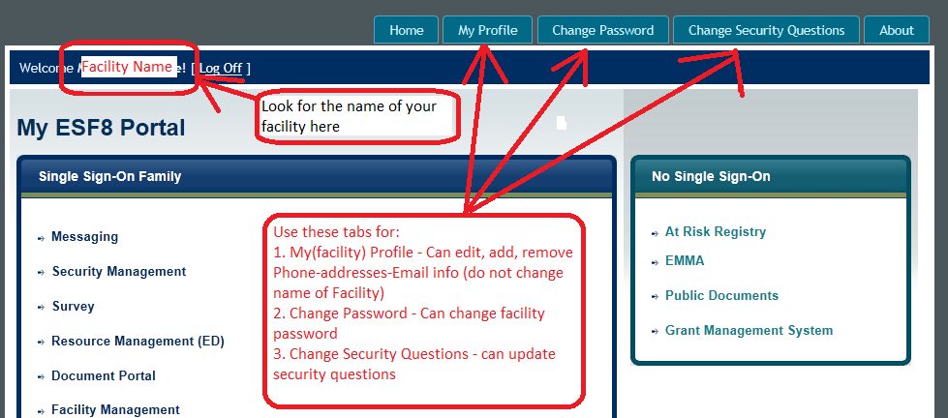
- Now for the two main applications that you will be using at this time:
- Security Management – this is where your facility’s User and Person account is found and where contact information for any “person” that will need to be notified for emergencies will be entered. Person – is emergency persons or contacts for your facility that maybe sent notifications regarding ESF-8 & ESF-8 portal applications. User - is a “person” who has an assigned Username and Password. The User for Nursing Homes and ARCP’s is the facility itself – i.e. the facility is assigned a Username & Password. This username and password will be given to the Facility Administrator so that they can update ESF-8 as needed. If needed the facility administrator can share the information with others but is responsible.
DO NOT DELETE or CHANGE the account listing (person or user) THAT HAS YOUR FACILITY’S NAME. DO NOT CHANGE the FACILITY POINT of CONTACT POSITION of the account listing THAT HAS YOUR FACILITY’S NAME.
You can change, edit or add phone numbers to facility’s account and you may add new persons (emergency contacts). For best possible chance of getting all ESF-8 messages give a person all 3 of these positions – Administrator + Emergency Preparedness + Facility Point of Contact.
- Mstat – this application replaced EMSTAT. When you open Mstat most will see their facility’s dashboard. This dashboard has 8 fields but you only need to update the following 7 –Statuses, Census, Utility Status, Manage Generators, Utility Providers, Transportation, and Evacuation Destination. You do not need to do anything with in Bed-type Mapping.
- Patient list will also need to be entered. Look for the “Patient” button at top right of page once you have opened and updated other areas of Mstat.
- Security Management – when you open Security Management you should see your facility’s name and any person(s) who have been linked to your facility. The facility’s name will be located in the “First Name” column and the type of facility listed as “Last Name”. DO NOT DELETE or CHANGE the account listing THAT HAS YOUR FACILITY’S NAME. DO NOT CHANGE the position FACILITY POINT of CONTACT POSITION of the account listing THAT HAS YOUR FACILITY’S NAME. You can change, edit or add phone numbers to facility’s account and you may add new persons (emergency contacts) or delete / edit any old outdated ones.
TO ENTER A NEW PERSON (remember Person is basically emergency contacts)
- Click “Add New” top right
- Enter general information – First & Last name, Signature (initials), work phone, work email. You may add more email addresses and phone numbers. You may need to enter one number or email address more than once – example if your business cell is also your primary work phone and the phone you receive business text msg. on you would enter it as each.
- Now pick the Position(s) of the person you have entered. If you want the person to get all information regarding the ESF-8 portal check at least these 3 positions – Administrator, Emergency Preparedness, Facility Point of Contact.
- Link the person to the facility. In the “Facilities” area click “Pick”. In the window that opens choose the parish that the facility is located and the type of facility then click “Search” and click box to check your facility. CLICK “PICK” (top) then SAVE(bottom). If you do not save you will lose your information. After you SAVE Click “Finish”. You should now see the person who you just entered.
- Mstat – there are 7 fields and the patient list that you will need to check and update as needed - Statuses, Census, Utility Status, Manage Generators, Utility Providers, Transportation, and Evacuation Destination:
- Statuses – you will enter the current status for Operations, Power (electricity), Evacuation, and Fuel (for generator). Once entered click, “SAVE CHANGES” or information will not be saved! You may need to enter a comment in comment box – nothing specific needed. Then click “Back”.
- There are 4 facility “Statuses” Operating Status; Evacuation Status; Power Status; and Fuel Status. A facility needs to enter current statuses and then update as needed. To enter or Update Statuses left click “Change” at lower right of “Statuses” field.
- Choose the option given that best describes the facility’s current status for each.
- You may be required to enter a comment – this can be anything from the initials or name of the person entering to the days date and a time.
- CLICK “SAVE CHANGES” or all of the changes will be lost. Click back to return to dashboard.
- During a reporting period if there are no status changes an update can be indicated by left clicking on “No Change”. This will be reflected in the “Last Update At:”

- Census – Census is equal to the number of residents a facility has or beds that are occupied or held at a given time. In order to correctly enter the census patients/residents need to be triaged into 3 categories Red/Yellow/Green based on their current transportation needs. Enter the number of patients/residents the facility has “In Facility” or “Out of Facility“ for each category. “Hosting Census” would only apply if you are hosting patients or residents from another facility. Residents “you are willing to host” is just that – at time you are entering – how many, if any, persons would you be willing to host? Total Facility Staff = total number of staff that work at the facility. Once entered click “SAVE CHANGES” or information will not be saved! You may need to enter a comment in comment box – nothing specific needed. Then click “SAVE CHANGES” then “Back”.
- Red - High risk patients that require ambulance support due to dependency on mechanical or electrical life sustaining devices.
- Yellow- Patients that are not mechanically dependent, but who cannot self/family evacuate nor can they evacuate using normal means (buses, vans, cars, etc.). For example, this category might include patients that cannot sit up to evacuate in a bus.
- Green- All other patients that can self/family evacuate or can evacuate using normal evacuation resources (buses, vans, cars, etc).
- In Facility – means person is currently in the facility
- Out of Facility – person has bed being held but will be out of facility for extended time – example this may be person at hospital or out with family/on leave.
- During a reporting period if there is NO change to census an update can be indicated by left clicking on “No Change”. This will be reflected in the “Last Update At:”

- Utility Status - does facility currently have phone, internet, water _ Yes or No? Once entered click ”SAVE CHANGES” or information will not be saved! You may need to enter a comment in comment box – nothing specific needed. Then click “Back”.
- Choose the option given that best describes the facility’s current status for each.
- Once entered click ”SAVE CHANGES” or information will not be saved
- You may need to enter a comment in comment box – nothing specific needed. Then click “SAVE CHANGES” then “Back”.
- During a reporting period if there is NO change to census an update can be indicated by left clicking on “No Change”. This will be reflected in the “Last Update At:”

- Manage Generators – this is where you will either edit generators that have been entered into Mstat or add new ones. You can also Manage Fuel Tanks for the Generators. Once entered click ”SAVE ” or information will not be saved! You may need to enter a comment in comment box – nothing specific needed. Then click “Back”.
- Left Click “Manage” in the Manage Generators” field
- Look under “Available Generators” to see if there are any generators currently entered.
- If no generators are listed you will need to “Add New Generator”
- If there is a generator listed you can edit or update if needed – or delete
- A facility may have multiple generators and fuel tanks
- To “Add New Generator” click ” Add New Generator” then enter the required information
- Operational: place a check here if this generator is connected to facility
- Burn Rate and Burn Rate Unit: How much fuel is burned per hour and give the unit of volume (Gallon, Cubic yard/meter, etc)
- Many generators require a fuel tank and Fuel Tank information will need to be entered under “Manage Fuel Tanks” and generator associated its tank.
- Services – what does generator supply power to? Place an “x” in each service powered by that generator.
- When complete click, “SAVE” or information will not be saved!
- “Revert” If editing an existing generator and you need to undo or change back click “Revert” Will not work once you save.
- Click “Back” to return to Dashboard.

- Utility Providers- add/edit the name of your utility providers – most importantly your electric utility – and the facility’s account #. Once entered click “SAVE” or information will not be saved! Then click “Back”.
- Left click “Manage” to open
- Add New Record or Edit as needed
- Left click “Add New Record” to enter a new utility provider. If the provider is listed you will see it appear in a dropdown list.
- If provider is not listed contact us and we will add provider.(see 4.a)
- Left click “Edit” or “Delete” to modify existing providers
- Once entered left click “SAVE” or information will not be saved! Then click “Back”.
- Transportation – this is where the names of transportation companies that facility will use if evacuation is necessary will be entered and edited. Click “Add or “Edit” enter or update information. Once entered left click “SAVE” or information will not be saved! Then click “Back”.
- Left click “Manage” to open
- Left click “Add” found upper right of window
- Enter the required information
- You may need to go through the regions in order to locate the correct parish.
- Once entered left click “SAVE” or information will not be saved! Then click “Back”.
- Evacuation Destination – this is where the facility’s evacuation destinations will be managed. Enter the location information of where the facility is planning on going (has agreements with) in case they have to evacuate. For “Licensed” Facilities you will be able to choose and “Pick” from licensed facility list but for non-licensed facilities you will need to enter all information. Once entered click “SAVE” or information will not be saved! Then click “Back”.
- Go To the bottom of the “dashboard Page” and find the area labeled “Evacuation Destinations” and click the “Manage” button
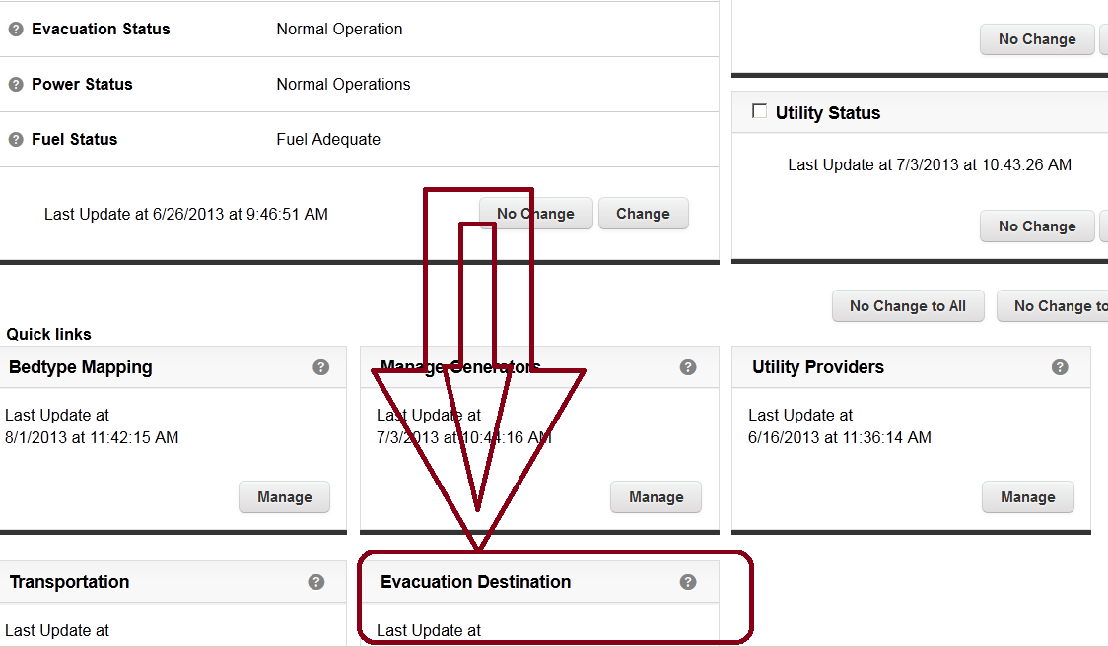
- If you need to enter a licensed facility as an evacuation destination use the field labeled “Licensed Facilities”
- Click “Add” – NOTE: only applies to facilities licensed in Louisiana. Be sure to pick region and parish or “Select”. If Out Of State selected a search will not be allowed. You can have “Select” or any of the other choices but you cannot use “Out Of State” for an IN State facility.
- In the window that opens either type in the facility name (or part of it) in the box labeled “Facility Name” then click search. Will display facilities that match.
- Or, use the selection criteria to narrow the search then click “Search” to display facilities that match criteria.
Example: If you type in “Colonial” all facilities with Colonial in the name will appear after you click “Search” Note that all other selection boxes have been set to __Select__
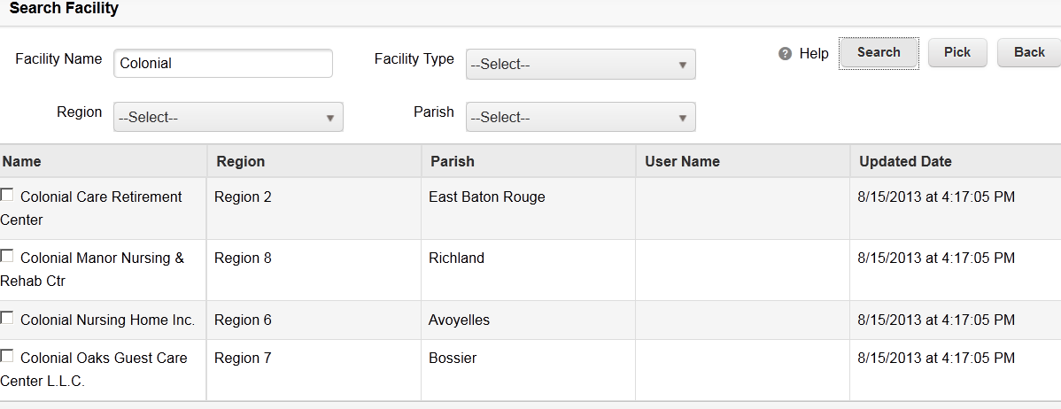
OR; use selection boxes to narrow search; by picking a facility type/ region/ and parish to narrow results:
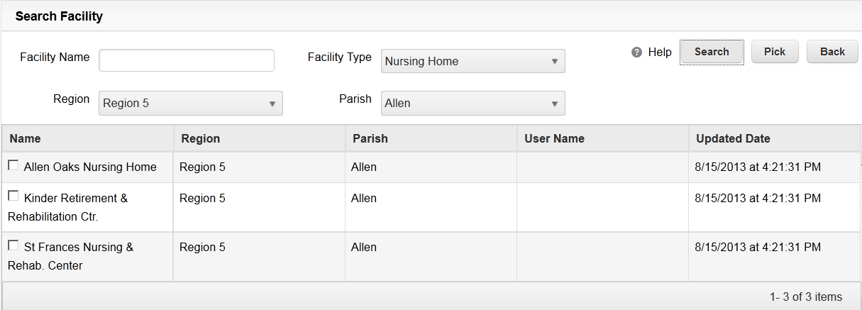
- Once you locate the facility put check in box in front of the name then click “Pick”
- If the facility is Not a Licensed Health Care Facility licensed by LaDHH then you will need to add it using the area labeled “Non Licensed Facilities”
- Click add
- Type in the Name of the Evacuation Site
- If site is in Louisiana select region then parish (choose a region to see its parishes)
- Enter other required information
- CLICK SAVE
All of the facilities added in this area will be available to pick from for use in the “Patient” list if you need to show an evacuation. If a facility is not listed here you will have to add it before being able to see and use it in “Patient List”.

- Patient- Click the word “Patient” at top right of window. This is where facility will enter the list of residents or patients. You can either enter each resident one at a time directly into the system OR “Download Template” an excel file that can be named, saved to computer then “Uploaded” into the system.
- Direct entry – enter each resident one at a time.
- Click “Patient “at top right of window.
- Click “Add Patient” enter the required information. Once entered click “SAVE” or information will not be saved! Then click “Back” OR repeat “Add Patient” for the next patient.
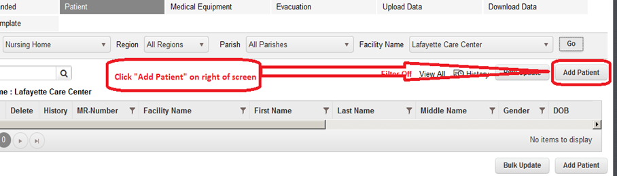

- Check and or Enter the correct information requested each field.
- Facility Type – what type of facility is it
- Facility Name – pick from the drop down list by clicking the name
- MRNumber (MR= medical record but can be any unique number for that resident/patient)
- First Name – resident/ patient’s first name
- Last Name - resident/ patient’s last name
- Gender – Female, Male, Unknown
- Evacuee Type – pick which best describes the evacuee
- Region – which of the 9 regions is facility located.
- Disposition - pick which currently best describes the evacuee’s location
- Middle Name – optional
- Date of Birth – use “mm/dd/yyyy” format
- Transportation Triage - what type of emergency transportation would be required if patient/resident had to be moved in an emergency: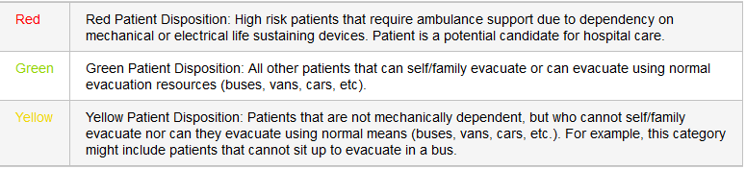

- Patient Medical Condition - Does resident/Patient require an electronic device (on = yes, off = no)
- Patient Evacuation- if you have entered the facility evacuation destinations( places where facility has agreements to evacuate to ) you can choose the destination from the list for each patient.
- Using template (the format of the template cannot be changed or modified) :
- Download the template by clicking the “ Download Template “ link which will be located along top of window:
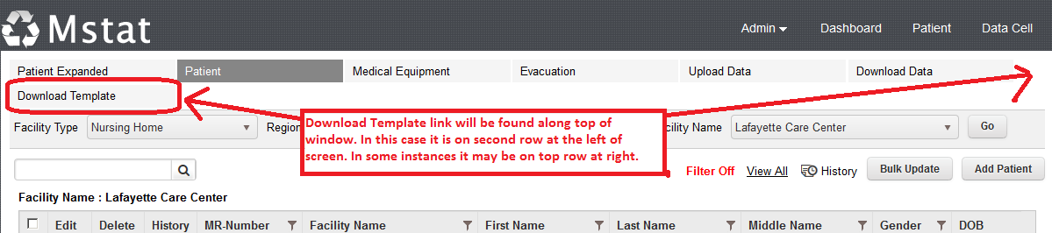

- You can “open” then save or just “Save file”. Be sure to name and save template to a place that you can find easily when you upload.
- The five (5) following items (columns) need to be completed for each resident for a successful upload of all residents: LastName, FirstName, MRNumber (MR= medical record but can be any unique number for that resident/patient), Gender, and DOB (date of birth), enter the required information into the template then save the template file to be “Uploaded” .
- The template will look like the following:
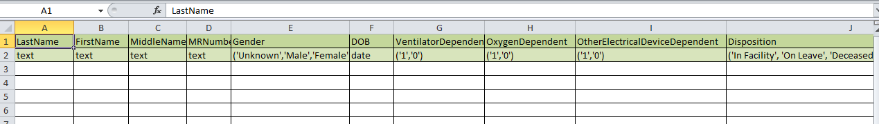
- You can type into the file or cut and paste if you are familiar with that process. You cannot change the format of the file. Do not change the first two rows.
- You can add more blank lines as needed – left click the row number(s) at left where you want to add rows and highlight a blank row(s) (or several blank rows) by right clicking then choose the “Insert” option. Repeat as needed.
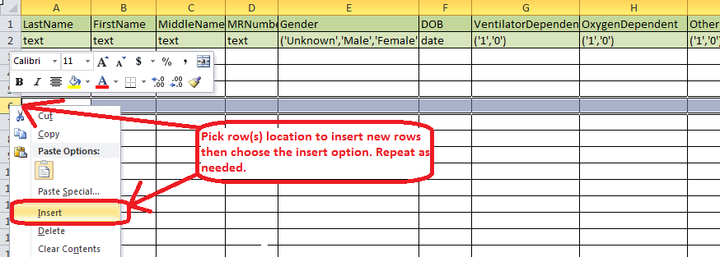
- Once required resident information has been added LastName, FirstName, MRNumber (MR= medical record but can be any unique number for that resident/patient), Gender, and DOB (date of birth)
- To Upload your saved file:
- Upload the template by clicking the “ Upload Data “ link which will be located along top of window
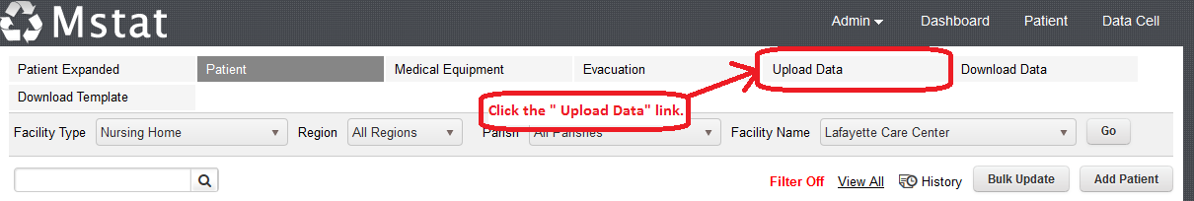
- When the “Upload Patient Data” window opens enter the requested data
Facility Type; Region; Facility Name; For new patients Choose Option “Add/Update Patients”
- To Upload the file you completed and saved click “Select Files” find the file you saved and double click. Once the file has been chosen there will be a link that appears “ Upload Files” click the link
- If the upload is 100% successful you should see the total number of records (this will be equal to number of residents/patients on your list) the Total Number of records updated (this is number updated successfully) and total number of records that failed to upload (equals total records less total updated) if all records successfully uploaded then “Total Number of Records Failed = 0”.
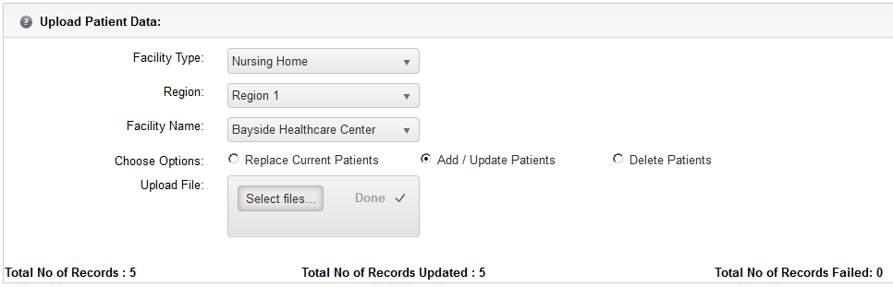
- To view your residents click “ Patient” at top
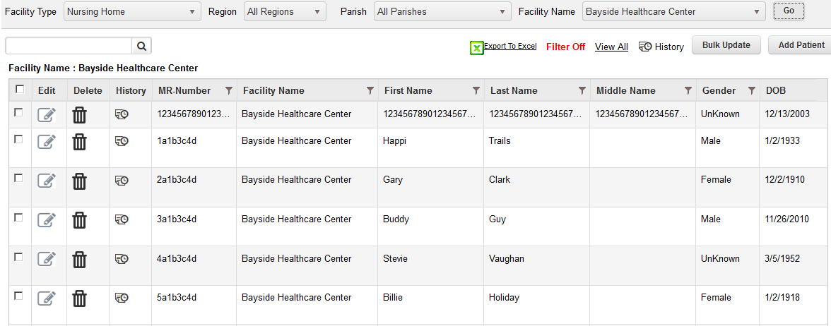

- Template for Adding or Deleting – You can use the template to add or delete residents. Example: add the names of resident(s) to be deleted and upload using the “Delete Patient” option. Or add new names to the template and use the “Add/update Patient” option. OR use a saved template that has all current information and remove and add residents the upload using the “Replace Current Patient” option.

